


VISVESVARAYA TECHNOLOGICAL UNIVERSITY

Jnana Sangama,Belagavi-590018

A INTERDISCIPLINARY PROJECT WORK REPORT (1BPRJ258) ON

“Freelancer Marketplace”
Submitted in partial fulfilment of the requirements for the award of the degree of

BACHELOR OF ENGINEERING IN
INFORMATION SCIENCE AND ENGINEERING
Submitted by
Under the Guidance of
Guide Name Designation, Department, CMRIT
Astha Anand 1CR25IS34
Avadhoot 1CR25IS35
Gahana J R 1CR25AI33
Gajula Thanuja Sri 1CR25AI33

DEPARTMENT OF INFORMATION SCIENCE AND ENGINEERING

CMR INSTITUTE OF TECHNOLOGY
AECS LAYOUT, ITPL PARK ROAD, BENGALURU - 560037 2025-26



CMR Institute of Technology
AECS Layout, Bengaluru-560037
Department of Information Science and Engineering

CERTIFICATE
Certified that the project work entitled “Freelancer Marketplace” is a Bonafide work carried out by:
Astha Anand 1CR25IS34
Avadhoot 1CR25IS35
Gahana J R 1CR25AI33
Gajula Thanuja Sri 1CR25AI33
in partial fulfillment for the award of the Bachelor of Engineering in Information Science and Engineering of Visvesvaraya Technological University, Belagavi during the year 2025–2026.It is certified that all corrections/suggestions indicated for internal assessment have been incorporated in the report deposited in the department library. The project report has been approved as it satisfies the academic requirements prescribed for the said degree.

----------------------------- -------------------------------

Signature of Guide Signature of HOD

Prof.Ciyamala Dr. Fazlur Rahaman

Asst.Professor HOD

Dept.of CSE, CMRIT Dept.of Chemistry, CMRIT

External Examiner:

Name of the Examiner Signature with date

ACKNOWLEDGMENT

I immensely grateful for the opportunity to undertake and successfully complete the challenging project titled “Freelancer Marketplace”. This endeavor marks a significant milestone in our academic and technical journey.

I would like to thank Dr.Sanjay Jain,Principal,CMRIT,Bangalore,for providing an excellent academic environment in the college and his never-ending support for the B.E program.

I would like to express my gratitude towards Dr. Fazlur Rahaman, HOD, Department of Chemistry, CMRIT, Bangalore, who provided guidance and gave valuable suggestions regarding the project.

I consider it a privilege and honor to express our sincere gratitude to my internal guide Prof.Ciyamala, Asst Professor, Dept. Of CSE CMRIT, Bangalore, for her valuable guidance throughout the tenure of this project work.

I would like to thank all the faculty members who have always been very coop- erative and generous. Conclusively, we also thank all the non-teaching staff and all others who have done immense help directly or indirectly during our project.

Astha Anand
Avadhoot
Gahana J R
Gajula Thanuja Sri

Abstract
The Freelancing Marketplace is a web-based platform designed to connect skilled freelancers with clients seeking various professional services such as graphic design, web development, content writing, digital marketing, and programming. The main objective of this project is to create an efficient, user-friendly, and secure environment where clients can post projects and freelancers can showcase their skills, bid for work, and complete tasks online.

This project focuses on solving common problems faced in traditional hiring methods, including limited reach, communication gaps, time consumption, and lack of transparency. The platform enables easy interaction between freelancers and clients through features such as user registration, profile management, project posting, bidding system, messaging, payment handling, and review/rating systems. These features help build trust, improve communication, and ensure smooth project management.

The Freelancing Marketplace is developed using modern web technologies and follows the principles of Innovation Design Thinking by identifying user needs, generating practical solutions, and improving user experience. The system aims to support students, professionals, and small businesses by providing flexible work opportunities and affordable services in a digital environment.

Overall, this project demonstrates how technology can simplify the process of hiring and working remotely while promoting entrepreneurship, skill development, and digital collaboration in today’s growing online economy.

List of Figures
  - Multimodal System Architecture for Parkinson’s Risk Assessment . 16
  - Preprocessing Steps for Digitized Spiral Drawing Images 18
  - Vertical System Flow Diagram of the Multimodal Parkinson’s Dis-
ease Detection System 21
  - MFCC Feature Extraction Process using Librosa 24
  - Workflow of the Proposed Multimodal CNN-Based Parkinson’s Dis-
ease Detection System 25
  - Comparison of Healthy and Parkinsonian Archimedean Spiral Draw-
ings 37
  - Spiral Drawing Analysis 44
  - Voice Recording Analysis 45
  - Assessment 46
  - Test set performance metrics and successful model saving after CNN training for Parkinson’s disease detection. 47
  - High Risk Prediction 51
  - Low Risk Prediction 52

TABLE OF CONTENTS

Contents

Abstract ii
List of Tables iii
List of Figures iv
Table of Contents v
- INTRODUCTION 1
  - Background 1
    - Motivation 2
    - Problem Statement 3
  - Objectives 3
  - Domain of the Project 4
- RELATED WORK 5
  - Paper 1: Association of Neurological Family Health History in Parkinson’s Diseases 5
  - Paper 2: Improvising Parkinson’s Disease Diagnosis: A Genetic Algorithm-Guided CNN Approach 6
  - Paper 3: Parkinson’s Disease Prediction Using Machine Learning Algorithm 6
  - Paper 4:Predictive Modeling for Early Parkinson’s Disease Diag-
nosis Using AI 7
  - Paper 5: Parkinson’s Disease Classification from Scanned Images
of Spiral Drawings 7
  - Paper 6: Speech Based Detection of Parkinson’s Disease 8
  - Paper 7: Voice-Based Deep Learning Medical Diagnosis System for Parkinson’s Disease Prediction 9
  - Paper 8: Detection based on voice using supervised machine learn-
ing 9
  - Paper 9: A Voice and Spiral Drawing Dataset for Parkinson’s Dis-
ease Detection and Mobile Application 10
  - Paper 10: An automated cloud-based tool for Screening of Parkin-
son’s disease in Bangladesh 10
  - Paper 11: Comparative Analysis of Biomarkers for Parkinson’s Dis-
ease 11
  - Paper 12: Parkinson’s disease diagnosis using machine learning and
voice 12
  - Paper 13: Multimodal Data Fusion and Machine Learning for In- tegrated Management of Parkinson’s Disease in Healthcare 12
  - Paper 14: Parkinson’s Detection on voice recording by Convolu- tional Neural Network 13
  - Paper 15: Parkinson detection by deep neural networks 14
- PROPOSED MODEL 15
  - System Overview 15
    - Multimodal System Architecture for Parkinson’s Risk As- sessment 15
      - Data Acquisition 17
      - Preprocessing 17
  - Flowgraph 19
    - Data Flow Diagram (DFD) for Multimodal Parkinson’s Dis-
ease Detection 19
  - System Block Diagram 19
    - Workflow of the Model 20
  - Process 22
    - Feature Extraction Module 22
  - Multi-Task Classification Network 24
    - Model Training Details 26
      - Training Data Preparation 26
      - Model Structure for Learning 28
      - Loss Function 28
      - Optimization Strategy 29
      - Data Augmentation 29
      - Regularization Techniques 29
      - Training Strategy 30
      - Evaluation Metrics During Training 30
    - Risk Level Classification 31
    - Result Interpretation and Visualization 32
      - Risk Prediction Output 32
      - Visual Result Representation 33
      - Explainability through Visual Indicators 33
      - User Feedback and Report Generation 33
      - System Reliability and Ethical Considerations 34
  - Advantages of Proposed Model 34
- IMPLEMENTATION 36
  - Training Phase 36
  - Inference Phase 38
  - User Interaction and Diagnosis Validation 39
  - Performance Evaluation 40
    - Evaluation Metrics 40
    - Detection and Classification Performance 41
    - Inference Speed and Computational Efficiency 41
    - Model Robustness and Generalization 42
    - Overall Performance Summary 42
  - React.js Frontend Interface for Data Submission and Results Display 44
  - Performance Metrics of the Trained CNN Model 45
- RESULT 48
  - Overall System Performance 49
  - Summary 51
- CONCLUSION AND THE FUTURE SCOPE 54
  - Conclusion 54
  - Future Scope 56
REFERENCES 58

Freelancer Marketplace
Chapter 1

INTRODUCTION

Freelancing has become one of the fastest-growing work models in the digital world. Many businesses and startups prefer hiring freelancers for project-based work instead of maintaining large permanent teams. Freelance Hub is developed as a modern freelancer marketplace website that connects freelancers and clients through a simple and user-friendly platform.
The website allows freelancers to showcase their skills, communicate with clients, and manage projects effectively. The platform also includes extra demo features such as Skill Verification Demo, Availability Calendar Demo, Messaging Demo, Reviews System, Scope Estimator Demo, and Admin Moderation Demo.
The main goal of the project is to provide a professional yet simple platform that improves trust, communication, and collaboration between freelancers and clients.

Brief History

The freelancing industry expanded rapidly with the growth of the internet and remote work culture. Platforms like Fiverr, Upwork, and Freelancer introduced online project hiring systems that made remote work easier across different countries.
Over time, users demanded better features such as profile verification, secure communication, project management, scheduling systems, and reviews. Modern freelancer platforms now focus on transparency, user experience, and efficient collaboration.
Inspired by these advancements, Freelance Hub is designed as a simplified freelancer marketplace website with modern UI and smart demo features.

Project Title

Chapter 2
About the project

The Freelance Hub project is designed to create an interactive freelancer marketplace platform where users can browse freelancer services, communicate through messaging systems, and manage project workflows efficiently.

2.1Problem Statement

Many freelancer platforms are difficult for beginners and small-scale users. Freelancers often struggle to build trust and showcase their skills effectively. Clients also face difficulties in identifying reliable freelancers and managing communication.
The lack of transparency, proper scheduling systems, and organized communication reduces the efficiency of traditional freelancer marketplaces.

Objective of the Project

The main objective of the project is to develop a modern freelancer marketplace website with simple navigation and useful demo features.
Objectives include:
    - Creating a clean and responsive UI
    - Improving communication between freelancers and clients
    - Providing skill verification and reviews
    - Demonstrating availability scheduling
    - Simulating project estimation and collaboration workflows

Proposed Solution
The proposed solution is a freelancer marketplace website called Freelance Hub. The platform includes:
    - Freelancer profile browsing
    - Messaging demo
    - Skill verification demo
    - Availability calendar demo
    - Review and rating system
    - Scope estimator demo
Project Title

    - Admin moderation demo
These features improve trust, communication, and user experience.

2.4 Advantages of Proposed Solution

    - Simple and modern user interface
    - Better communication system
    - Improved transparency through reviews and ratings
    - Efficient project planning support
    - Availability tracking for freelancers
    - Responsive design for different devices
    - Easy navigation and clean workflow

Chapter 3
DESIGN

The project follows a frontend-focused design approach combined with modular feature implementation. The interface is designed to simulate a professional freelancer marketplace experience.

Description of Approach to Solve the Problem

The project uses a responsive card-based UI structure to organize freelancer services and platform features clearly.
The design focuses on:
    - User-friendly navigation
    - Responsive layouts
    - Interactive feature demos
    - Organized visual hierarchy
    - Better readability and usability

3.2Methodology

Step1-Requirements Analysis
Step2-UI Planning and wireframing
Step3-Fronted Development
Step4-Features Integration
Step5-Testing and Optimization
Step6-Final Deployment Preparation

3.3Prototype Description
The prototype includes multiple screens and interactive sections designed to simulate a real freelancer marketplace.

Project Title
Main sections include:
    - Homepage
    - Featured Work Section
    - Messaging Demo
    - Availability Calendar Demo
    - Skill Verification Demo
    - Scope Estimator Demo
    - Review and Rating System
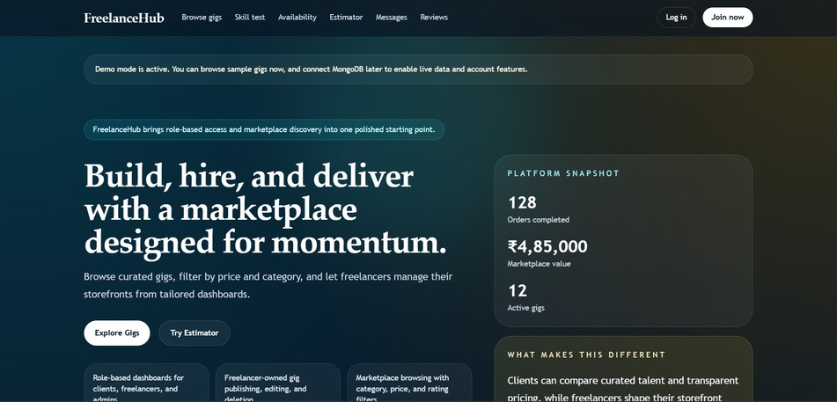
The website uses modern dark-themed UI with responsive layouts and clean typography.
Fig 3.1


Fig 3.2

Project Title

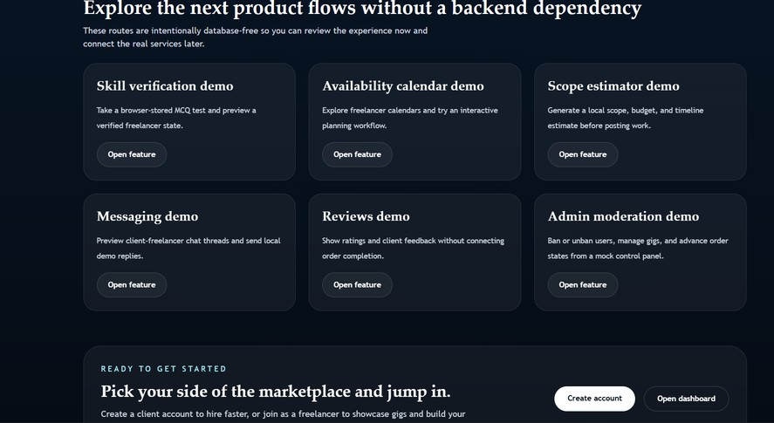

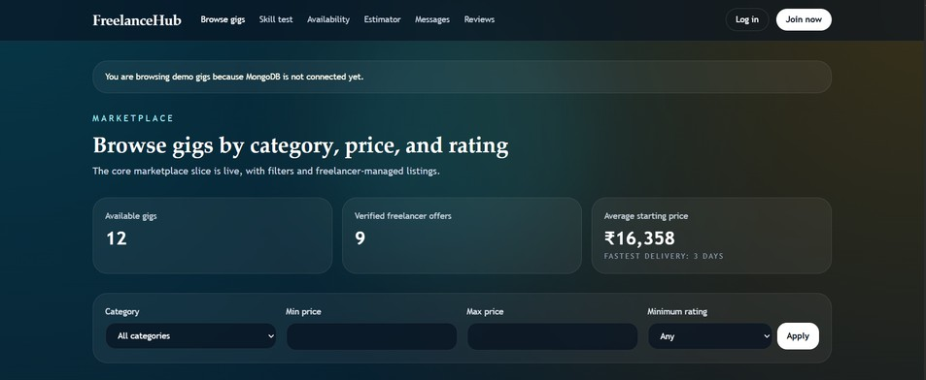
Fig 3.3
Fig 3.4
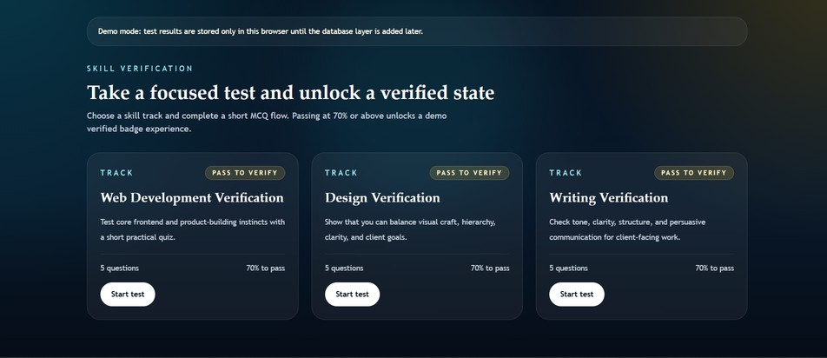

Fig 3.5

Project Title

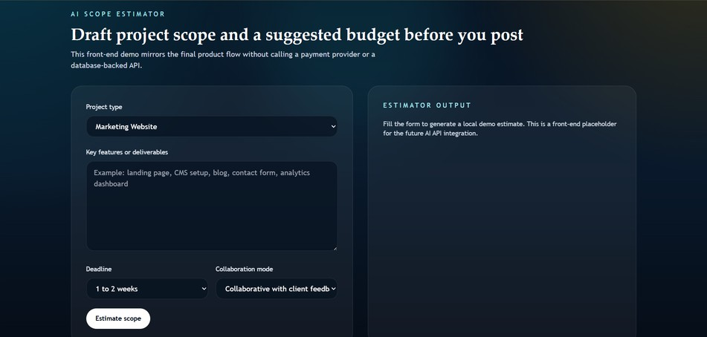

Fig 3.6

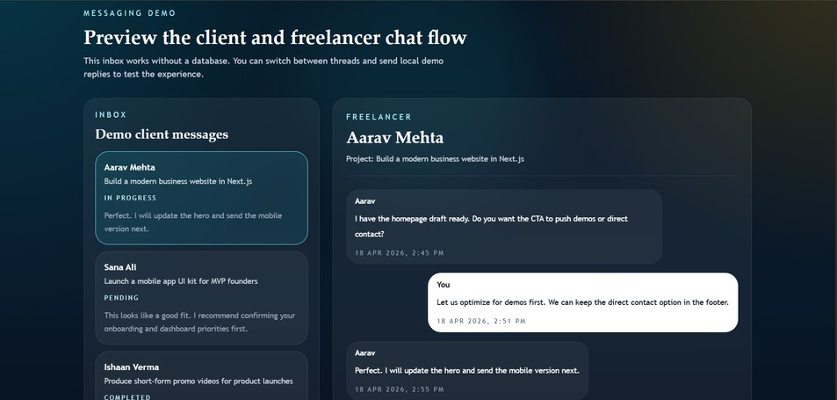

Fig 3.7

Project Title

CHAPTER 4
CODE SNIPPETS AND DESCRIPTION
The project frontend is developed using HTML, CSS, JavaScript, and modern UI styling libraries. The backend concept can be implemented using Node.js or Python Flask with MongoDB or MySQL databases.
4.1Fronted Structure
Example navigation structure:
Browse gigs
Skills
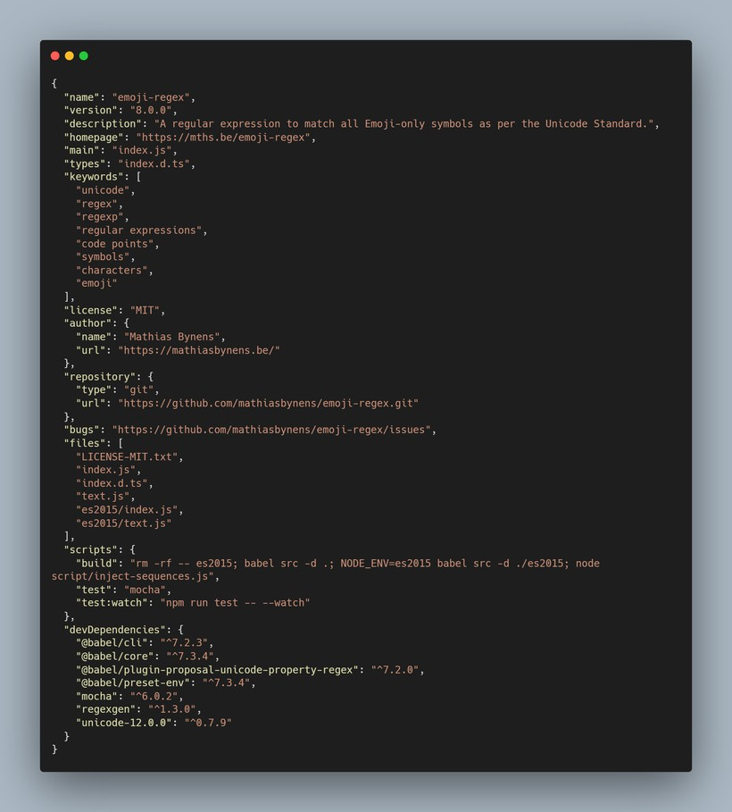
Availability
Fig 4.1

Project Title

Backend Concept

The backend manages:
    - User authentication
    - Freelancer profiles
    - Messaging system
    - Reviews and ratings
    - Project management
Possible technologies:
    - Node.js
    - Express.js
    - Python Flask
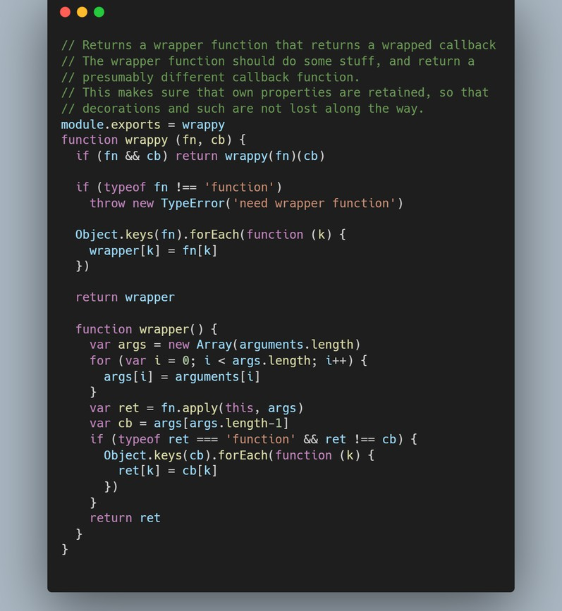
    - MongoDB

Fig 4.2
Project Title

Fig 4.3
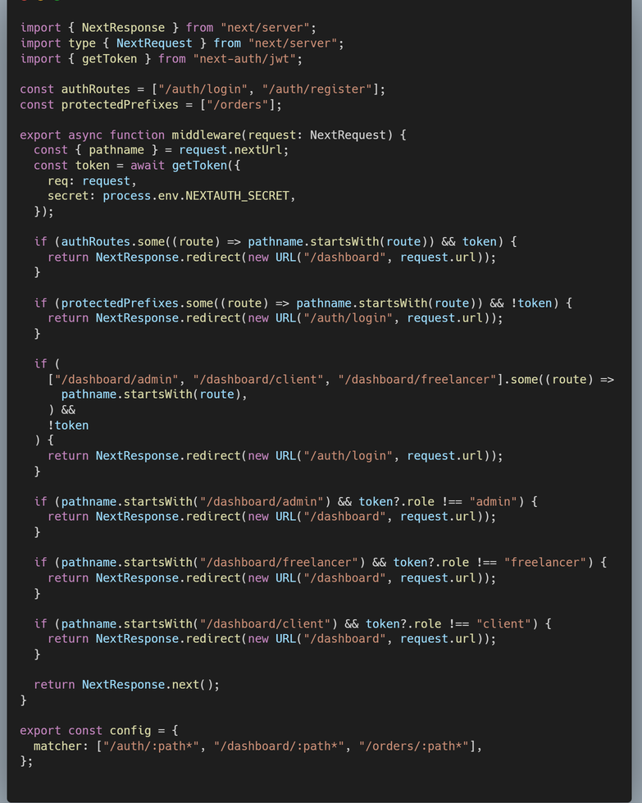
Project Title

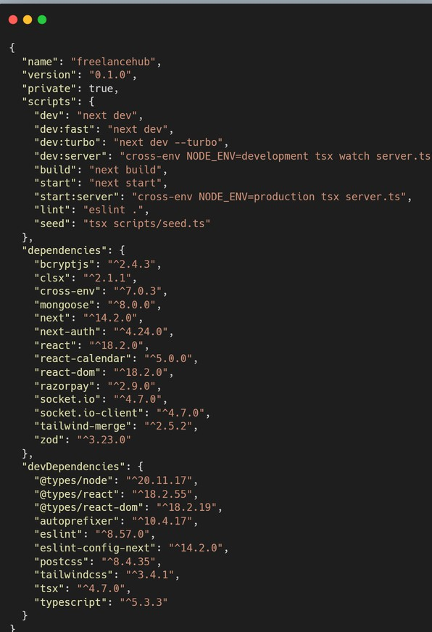

Fig 4.4

Project Title

Database Design
Database tables include:
    - User Table
    - Freelancer Profile Table
    - Project Table
    - Messaging Table
The database structure supports scalability and future feature integration.

Messaging and Demo Modules
The website includes multiple interactive demo modules such as:
    - Messaging Demo
    - Skill Verification Demo
    - Availability Calendar Demo
    - Reviews Demo
    - Scope Estimator Demo
    - Admin Moderation Demo
These modules simulate real freelancer marketplace workflows.
Chapter 5
Conclusion

The FreelanceHub project successfully demonstrates a modern freelancer marketplace platform with interactive features and responsive design.
The platform improves communication, transparency, and collaboration between freelancers and clients through smart demo modules and clean UI design.
The project can be further enhanced by integrating authentication systems, payment gateways, real-time databases, and advanced backend services.

Chapter 6
References

- HTML Documentation – https://developer.mozilla.org/
- CSS Documentation – https://developer.mozilla.org/
- JavaScript Documentation – https://developer.mozilla.org/
- React Official Website – https://react.dev/
- Tailwind CSS Documentation – https://tailwindcss.com/
- Node.js Documentation – https://nodejs.org/
- MongoDB Documentation – https://www.mongodb.com/
- Fiverr Platform – https://www.fiverr.com/
- Upwork Platform – https://www.upwork.com/

